Memristor Emulator 1



Simulating the circuit in OrCad Pspice gave following results

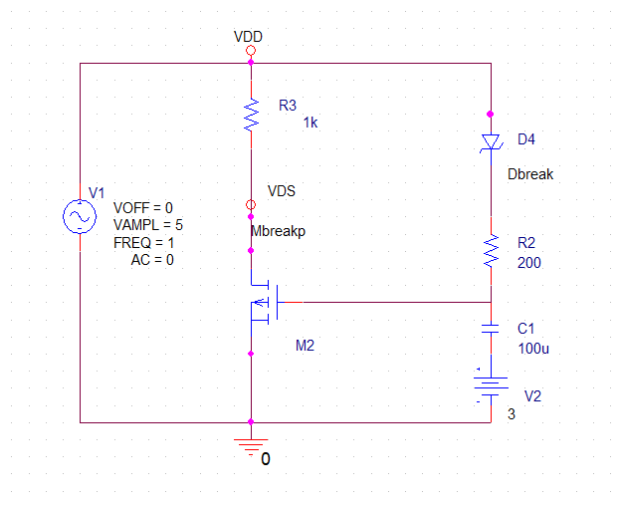

MbreakP Specified Parameters:

$$K=k_{n}\frac{w}{2L}$$

$$k_{n}=μ_{n}C_{ox}$$

Setting these values as follows:

$$k_{n}=0.05$$

$$V_{Th}=-1V$$

$$w=2.5μ$$

$$L=0.25μ$$

DbreakZ as Zener diode with following parameters:

$$V_{z}=BV=1V$$

$$C_{jo}=0.1pF$$

$$I_{s}=1×{10}^{-14}$$

$$R_{s}=0.1$$

It gave the following shape of pinched hysterises loop

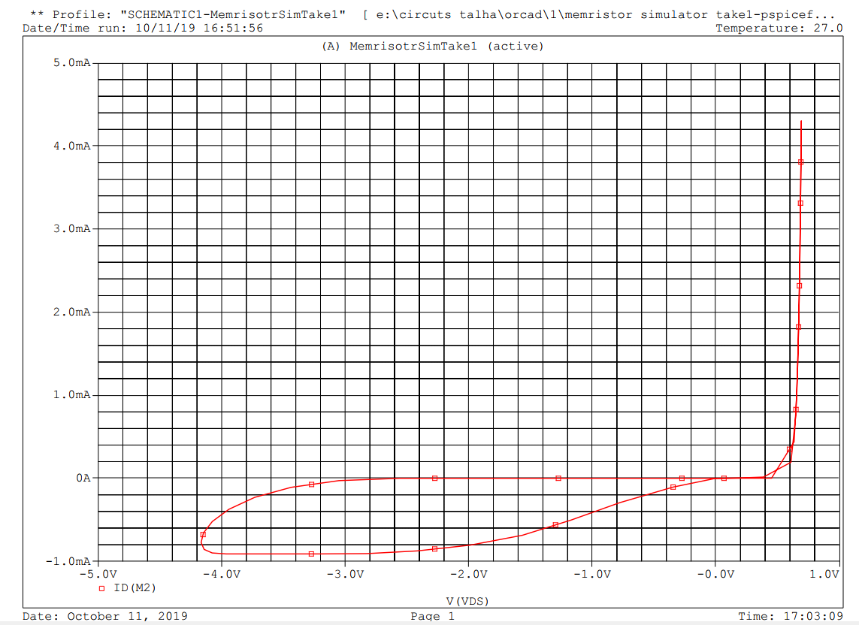

Curves of Vgs and Id are as follows;

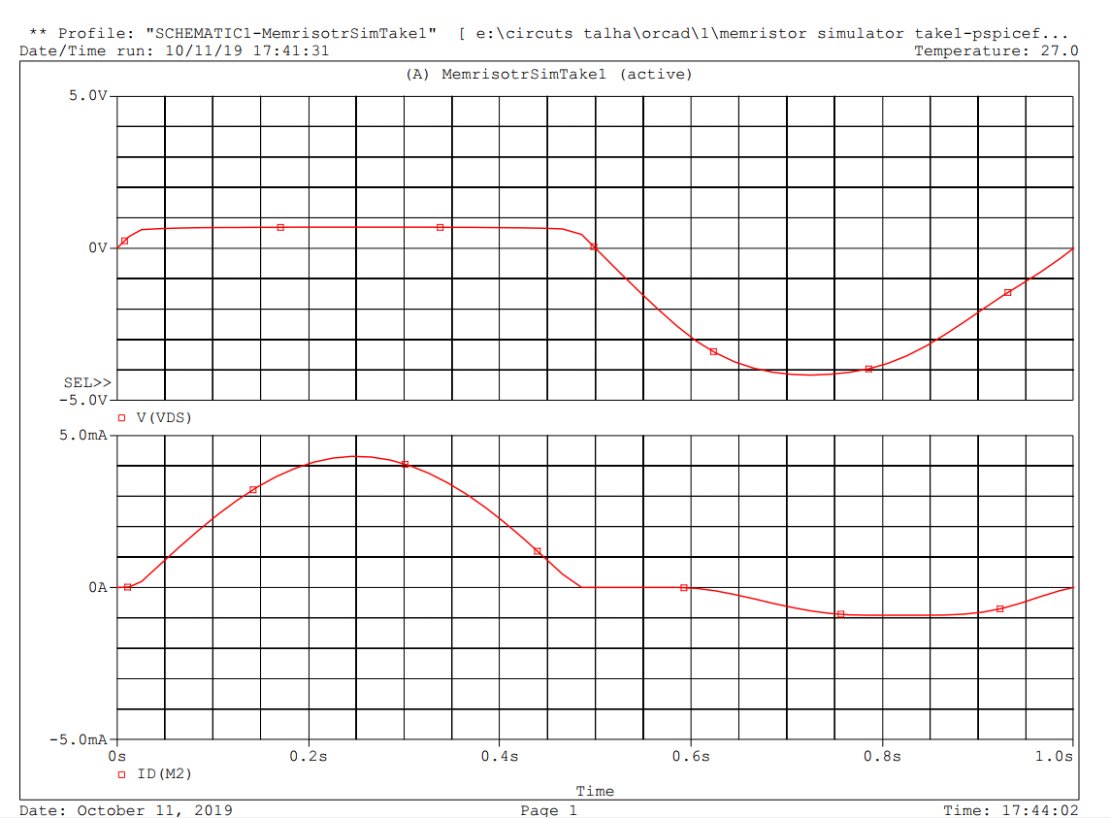

Modifying the above circuit for now as follows;

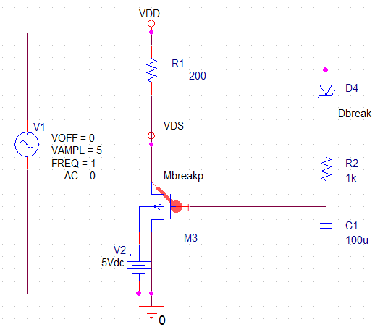

It gives the following output of pinched hysterics loop;(Capacitor Initial Voltage=-3V)

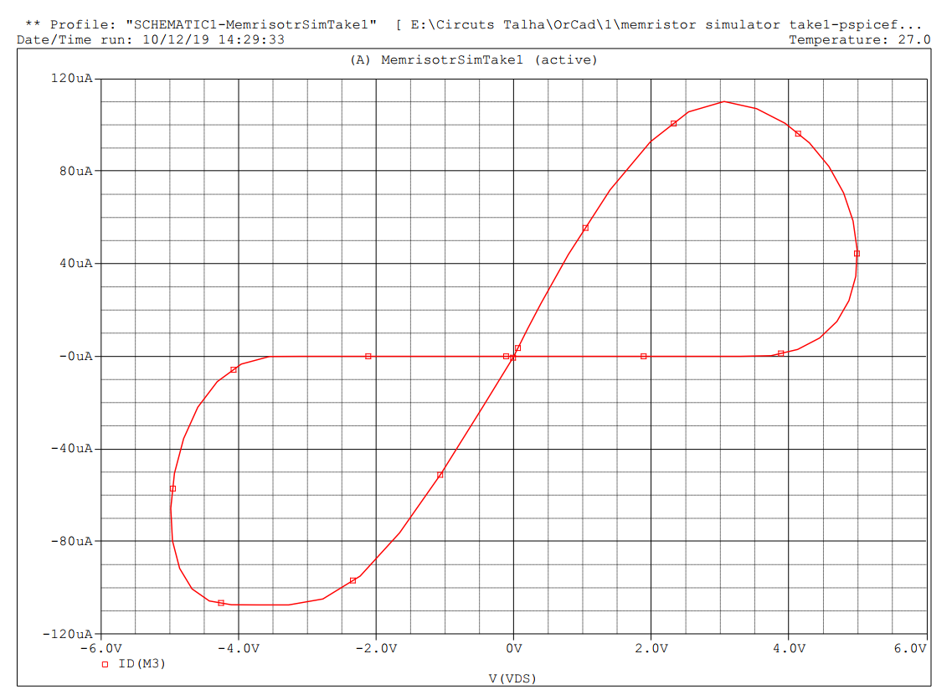

Curves of Vgs and Id are as follows;

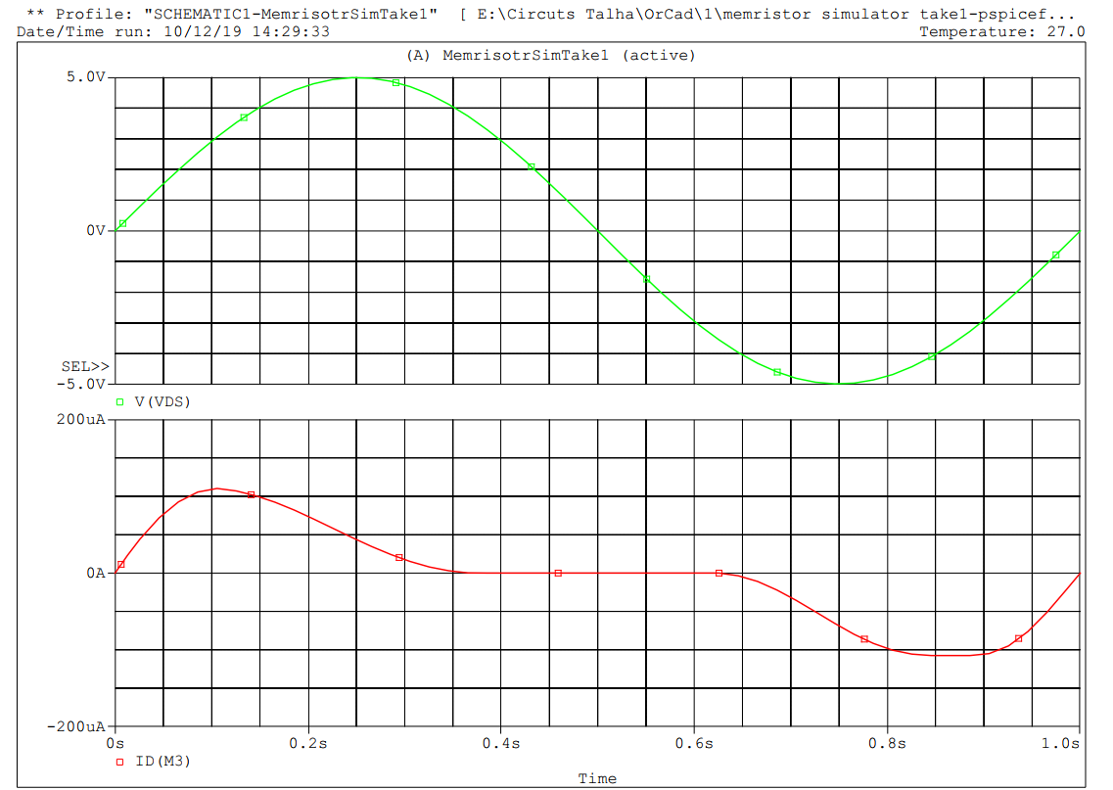

Looking closely why the current is zero from 0.36 secnds to 0.651 seconds lets look at the Vgs and Vds voltage curves (Here Vth=-1V)

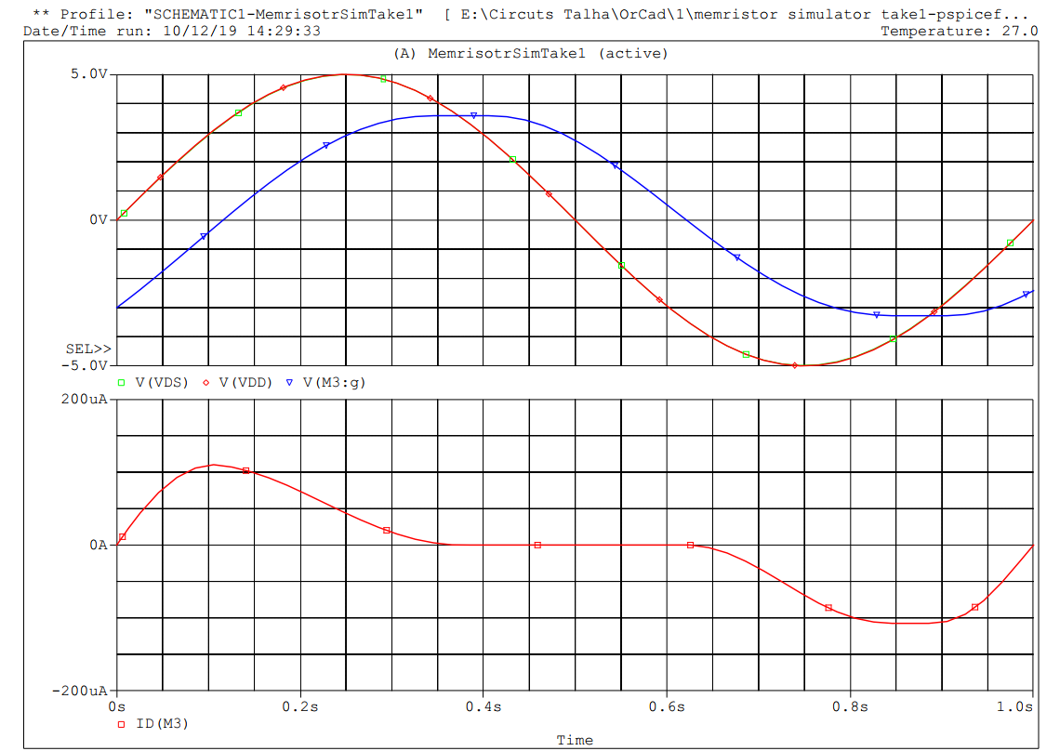

Above graph shows that form 0sec to 0.4 sec

$$V_{DS}≥V_{GS}-V_{th}$$

So,

$$I_{D}=K[2\left(V_{GS}-V_{th}\right)V_{DS}-{V_{DS}}^{2}]$$

Which means that the MOSFET is in Triode/Ohmic region, but after 0.4 sec as Vgs starts dropping from its peak value and falls below Vgs i.e.

$$V_{GS}≥V_{th}$$

Which means it goes into Cut-off region so;

$$I_{D}=0$$

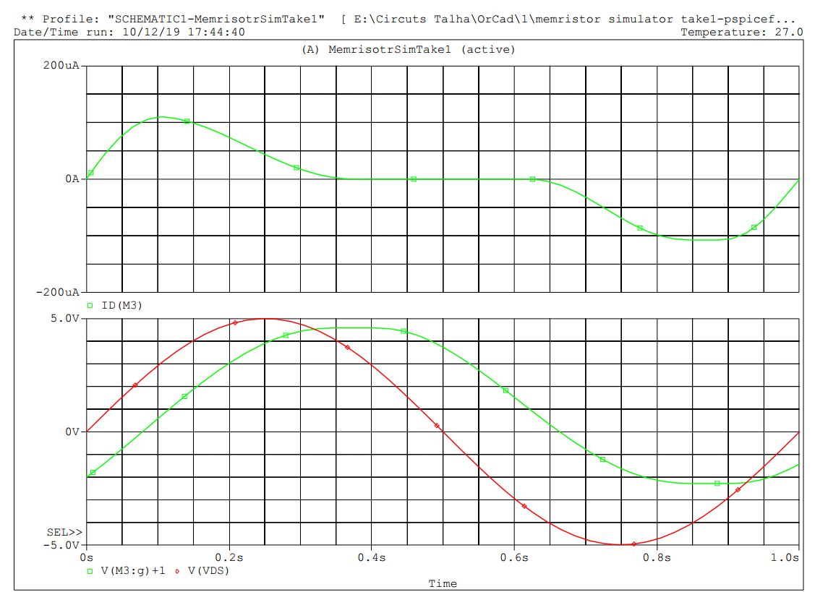

Between vgs – vthh and vds and Id seperate

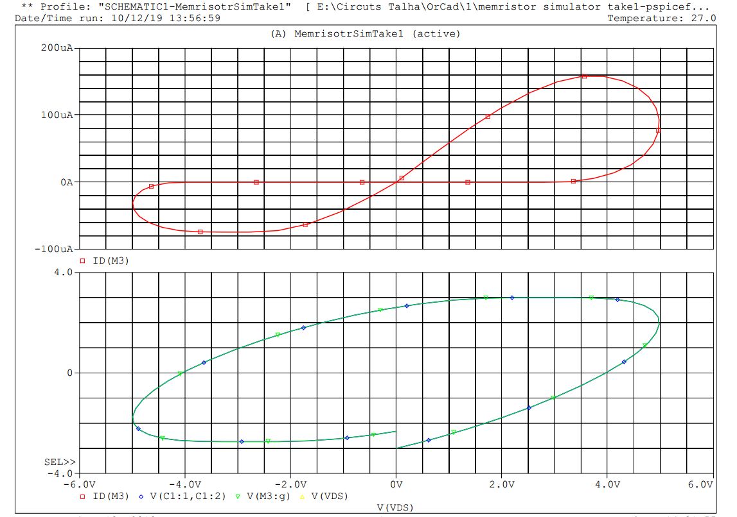

Vds vs Vgs and Vds vs Id